FrameWork 6/15
Jordy Hamilton on Patrick Howlett

unitholders; symbols, forms, language, playing fields, copies, surrogates, rules, maps, currency, structure, consciousness, value…

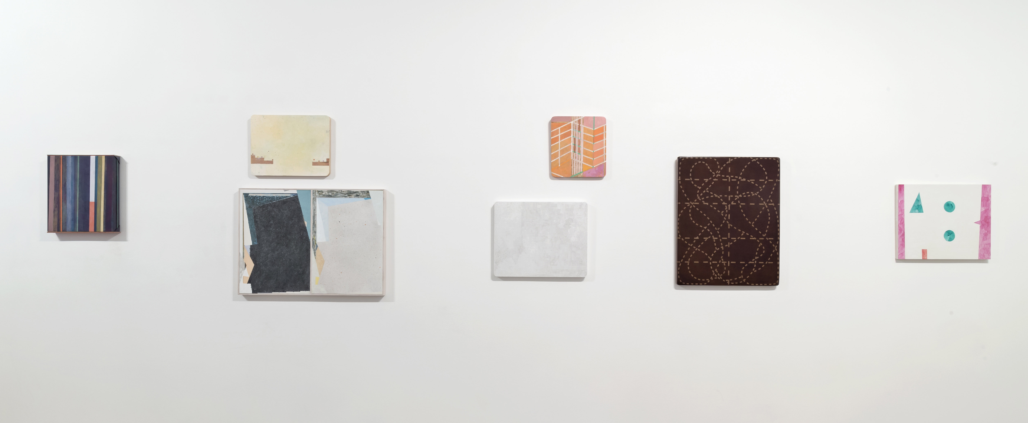

It can be said that Patrick Howlett’s paintings are symbols from the first—prior to any acknowledgement of the language, colours and signs (or lack thereof) at work inside their frame. Howlett has previously expressed an interest in framing; his current exhibition of works, unitholders, and the accompanying titles speak to this concern. I will attempt here to tease out a response. In doing this, I want to start by discussing a couple threads that I have been thinking about for some time. One stems from a reading I did a few years ago of a text titled, The Coiners of Language, by Jean-Joseph Goux. The other, stems from a lecture given by Diedrich Diederichsen at Los Angeles’ MOCA on the occasion of a survey exhibition for Martin Kippenberger. Both develop an important reflection on the relationship between form and content.

In The Coiners of Language, Goux takes as one point of interest, Andre Gide’s 1925 novel The Counterfeiters. Gide’s story is composed of several interwoven narratives but the central story revolves around a writer, Edouard, who is working on a book to be titled The Counterfeiters. In this self-reflexive and often cubist-feeling story, Gide’s central aim seems an inquiry into the elements that differentiate an original from a copy. Literary form is Gide’s primary interest I think, but in one of his story’s subplots, readers find young school boys passing off fake gold coins. As one character throws a coin on the table:

“Just hear how true it rings. Almost the same sound as the real one. One would swear it was gold. I was taken in this morning, just as the grocer who passed it on to me had been taken in himself, he told me. It isn’t quite the same weight, I think; but it has the brightness and the sound of a real piece; it is coated with gold, so that, all the same, it is worth a little more than two sous; but it’s made of glass. It’ll wear transparent. No; don’t rub it: you’ll spoil it. One can almost see through it, as it is.”(Gide)

Goux, in his reading of Gide, is interested in the counterfeit, the forgery, and the surrogate but perhaps more so in locating developments in the arts within an historical context. Gide’s novel was written close to the year 1924, when France removed the gold standard. Goux links this particular moment in economic history to the moment when realism gives way to a crisis of representation, arguing that forms of artistic abstraction emerge alongside those of financial abstraction. When the relationship between currency and gold dissolves, when value is easily and invisibly manipulated, people lose faith. They get suspicious and they begin to divest, or rather, invest differently. In such an environment, judging and estimating the historical value of artworks becomes increasingly difficult. Is this a good painting? Or a good painting of a bad painting? Or a bad painting made by a good artist pretending to make bad paintings? It’s a confusing business.

Fast-forward sixty or seventy years and the counterfeit remains an interest for artists, linguists, and theorists. In Diederichsen’s talk about Martin Kippenberger and the punk community he participated in, he outlines the artist’s interest in semantic networks both inside and outside of art. For Kippenberger, the value that signs produce—and the inequality that sources of power produce while using them—was a primary subject matter in the artist’s output. Diederichsen claims that one of the guiding principles of punk was to make explicit or “to expose that everything is about something.” The meaning derived from a sign is always dependent on who owns or employs the sign and how they do so. To be forthcoming about ones position within the network and about the signs one uses was, for him, central to being an artist. Kippenberger found art’s rather bourgeois and often traditional tendencies funny… something at once to participate in, to talk and laugh about, and to criticize. Key in understanding Kippenberger is that he used painting because it was the medium that most readily symbolized “Art”. Less interested in its long and lauded history, the decision to use painting and its formal language as a medium then became secondary to the content. For Kippenberger exclaims Diederichsen, the “enemies of the day were vagueness and spirituality.” A lot of the art that follows from this attitude is valuable in its ability to expose art’s often contradictory hopes and desires—it pictures a complex network of forces and blind spots. Kippenberger’s work was generous in its ceaseless rumination on the blind spots. In unitholders, I see some of this rumination.

unitholders takes an interest in both the verb, to paint, and the category that is painting. As such, the show exhibits an interest in framing and in being explicit about what painting is. In Howlett’s prior exhibitions, titles are said to be generative —a sentence or phrase might, through a process of translation, lead to an image. Here, titles seem more an addendum, and are seemingly explicit in their content. There are signs within these paintings but many of the works remain ambiguous. Titles like, system of the series, divisions and returns, and stakeholder present viewers with a more concrete textual conversation about value creation. And then there are the titles that reference repetition and cyclical behavior. Numbered titles like unitholder 6020, generic labour, and new trends lead me to think about painting’s often-repetitive history and the action involved in making them. In a mind free from worry, two paintings developed around the same form are framed in one frame side by side. The title seems to be a humorous poke at those adherents to painting’s redemptive or meditative qualities…to process. Finally, in a small work on paper titled flexible solutions, the sentence “make shelf ptgs” appears to offer up options: to make some good furniture in lieu of a bad painting? or perhaps a good painting rather than a purposeful piece of furniture? Howlett appears to take the second route.

This combination of text, titles, and image takes a seeming interest in the context, framing, and conditions under which a work of contemporary art is made. Formally though, on the surface of the paintings themselves, these ideas are harder to locate. The signs and symbols in the paintings point to this language but in a rather oblique way. Painting is hard to talk about they say. I read somewhere that Howlett was working through modernist forms in order to see of what use they might be today. Conceptual art’s skeptics often claim that abstraction is useful for its complicated, impenetrable, and ambiguous qualities. In the same vein, a curator once told me that he didn’t want to think in front of an abstract painting. For me, these works straddle the figurative/abstract relationship in a productive way. They point in many directions. They are all types of paintings and in this way the exhibition and Howlett’s practice can be read. For Howlett, seemingly modern abstract grids are actually paintings of shelves. The geometric ground of a painting might be a dance floor, a playing field, or a landscape.

Alongside this interest in modernist design and architecture I see brick walls, mazes, green houses, pre-game strategy, bar graphs, the play book, arrows, statistics, stamped letters (I, O, U), some faux bois, three sizes of masking tape, cardiograms, screens, and then the play with frames and nails, patterns on patterns, cells, the cross hatch, and for me most interestingly, the continuous use of the hatched path or line which we usually find on the map we are given when we participate in a treasure hunt. But, where is the value?

And so, I want to return to Gide’s golden coin. As the story goes, when you rub the gilded layer of a fraudulent coin for too long it wears off and reveals its transparent core. A lot of the art I see feels this way. Thin, weak, unearned, maybe even fraudulent. Some of it is better for this, in that it withholds something we as viewers expect, but most is bad, most is manner. unitholders feels at once confounding and explicit. These works are not glib. It is clear in viewing this show that Howlett is engaged in a deep conversation with the history of picture making and that his paintings deal with questions of surface, depth, colour and light in a compelling way. To be making long term work in a seemingly short-term world feels odd maybe but necessary. While the paintings themselves may not be explicit about their role in the architecture of art I do feel that the titling of this exhibition is. The individual titles of the paintings help highlight elements in the work that aim to address this question of value. In this, Howlett seems intent on addressing his own blurry relationship to value creation. The question for the viewer then is, what happens when you rub this exhibition as you would that coin? For me the combination of title and image weaves a dense web that I do not see through. I am left engaged and a little confused. Perhaps, pleasantly so.

Diederichsen, Deidrich, Martin Kippenberger; The Problem Perspective http://sites.moca.org/thecurve/2008/10/03/diedrich-diederichsen-on-martin-kippenberger/, MOCA, Los Angeles, 2008

Gide, A, The Counterfieters, Alfred A. Knopf, 1927

Goux, J. J, The Coiners of Language. Norman: University of Oklahoma Press. Translated by Jennifer Curtiss Gage. 1994

